**Chatbot**

**Name : Rahul prasad &**

**G.vamshi**

**Roll No : 49 & 58**

**Reg No : 11802325 & 11801585**

**Section : K18JC**

**Submitted to : Sagar Pande Sir**

**ARTIFICIAL INTELLIGENCE**

**CONTENTS:**

* **Introduction:**
* Aim and Purpose
* Scope
* Concept of Artificial Personal Assistant
* **Hardware and Software Requirements:**
* Hardware components
* Software Components
* **Working of an Artificial Personal Assistant:**
* Working and its layers
* **Available Applications Globally:**
* Comparisions
* **Features of Personal Assistant**
* **User Interface**
* **Advantages and disadvantages of Personal Assistant**
* **Personal Voice Assistants in future**
* **Conclusion**

**Introduction :**

Chatbots are software agents that can understand humans questions by analysing the data (message) .there are many chatbots used in many various industries like industries, hospital, general purpose and Google’s Assistant is also one of the most popular chatbot which can able to understand both message , voice assistants and are embedded in smartphones or dedicated home speakers. Users can ask their assistants questions, control home automation devices and media playback via voice, and manage other basic tasks such as email, to-do lists, and calendars with verbal commands. This column will explore the basic workings and common features of today’s chatbots. It will also discuss some of the privacy and security issues inherent to chatbot and some potential future uses for these devices. As chatbot become more widely used, librarians will want to be familiar with their operation and perhaps consider them as a means to deliver library services and materials.

**Aim and Purpose:**

The aim of the project is to provide personal assistant using text mode operation. This program includes the functions to reply user as per the given reflection to chatbot.

As it integrates most of the websites, services for daily use, it could be useful for getting a more convenient life and it will be helpful for those people who have disabilities for manual operations. This is also part of the reason why it has been chosen as our project.

**What is chatbot?**

A **chatbot** is a piece of [software](https://en.m.wikipedia.org/wiki/Software_agent) that conducts a [conversation](https://en.m.wikipedia.org/wiki/Conversation) via auditory or textual methods. Such programs are often designed to convincingly simulate how a human would behave as a conversational partner, although as of 2019, they are far short of being able to pass the [Turing test](https://en.m.wikipedia.org/wiki/Turing_test). Chatbots are typically used in [dialog systems](https://en.m.wikipedia.org/wiki/Dialog_system) for various practical purposes including customer service or information acquisition. Some chatbots use sophisticated [natural language processing](https://en.m.wikipedia.org/wiki/Natural_language_processing) systems, but many simpler ones scan for keywords within the input, then pull a reply with the most matching keywords, or the most similar wording pattern, from a [database](https://en.m.wikipedia.org/wiki/Database).

**Scope:**

The scope of the project is to build a program that will be able to serve like a human personal assistant. This is an interesting concept and many people around the globe are working on it. Now-a-days time and security are the two main things to which people are more sensitive: Nobody has the time to get spoil and nobody would like their security on breach. And this project is mainly for those kinds of people.

**Concept of an chatbot:**

Chatbot works on artificial intelligence which understands natural language by matching with patterns and completes tasks for the user. The assistant that I designed works on the basis of source code python.

It is a chatbot purely based on recognize pattern of the question .we can able to know any thing it will give us the response. This project is a combination of

* Automatic pattern recognition
* To understand pattern.
* Artificial Intelligence
* To understand command according to user’s input.
* Natural Language Processing
* To learn things from the user and to store all information about the user behavior and relationship.
* Inter Process Commmunication
* To get important information from other software Applications.

**Hardware Requirements :**

* **Hardware**
* A phone with a touchscreen interface,typepad.
* Connectivity on the basis of type of chatbot
* Mibile has to be connected to the internet to get response on the basis of marketing,any search.

**Working of chatbot:**

Any Personal Assistant basically consists of three layers. They are

1. Text recognition
2. Matching the patterns
3. Giving reflection.
4. **Text recognition**

* The message is stored in given data type.

1. **Matching the patterns**

* The given message being analyseed.
* Pattern are recognised by the chatbot.the pattern are placed in pattern section.

1. **Giving reflection**

* Chatbot analyse the patterns and give the response on the basis of the given reflections.
* If the patterns are not matched .it will give us the default response.

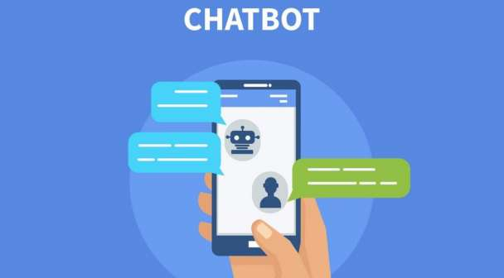

**Features of chatbot :**

Some features of chatbot used in day by day in our daily life are as shown below.

Conversations are, of course, at the core of every chatbot. Advanced artificial intelligence language techniques along with machine learning technologies power your chatbot's every conversation, from hello to complex queries.

[Natural language processing (NLP)](https://www.ubisend.com/features/natural-language-processing)

Small talk (hi, hello, how are you, etc.)

Context management, [natural language understanding](https://www.ubisend.com/features/natural-language-understanding)

Entity and intent detection

**Omnichannel:**

Your chatbot is built with an omnichannel approach in mind. Deploy it on one, or multiple channels, at the same time, allowing your users to engage wherever it is most convenient. Perhaps even only make some features available on certain channels. Put your chatbot where your users are, rather than force your users to come to you.

Website live chat

Facebook Messenger

Full-page takeover

WeChat

WhatsApp

Telegram

And many more...

**CONVERSATIONAL UX:** Providing a superb conversational experience to users is paramount. Your chatbot is your brand and must act as such. A series of features ensure your users get the most out of every interaction.

Onboarding sequences and testing

Frequently asked questions

Exit features

Fallback to human

Sharing and virality

**BRAND:**

Your chatbot must represent your brand. Every aspect of the chat experience is customisable to ensure you retain maximum control over its branding.

Rich media

Widget appearance

Full-page appearance

Icons

Emoticons

Use of humour

**Analaytics and Reporting:**

You can't improve what you can't measure. Every chatbot is shipped with its own, custom dashboard. Monitor your progress via the metrics you and your business care about.

Engagement metrics

Retention metrics

Drop-off metrics

Funnels

Any custom metrics

Data to and from your own services

**PRIVACY AND SECURITY:**

Protecting your users' privacy and keeping your data secure is of utmost priority. We work closely with you to make sure you understand and retain control over whatever you deem necessary.

No external AI providers (Google, Facebook, Amazon etc.

Deployment to specific services and locations

Deployment into your data perimeter

Deployment onto your own servers

User 2FA and identity confirmation

Secure code repositories

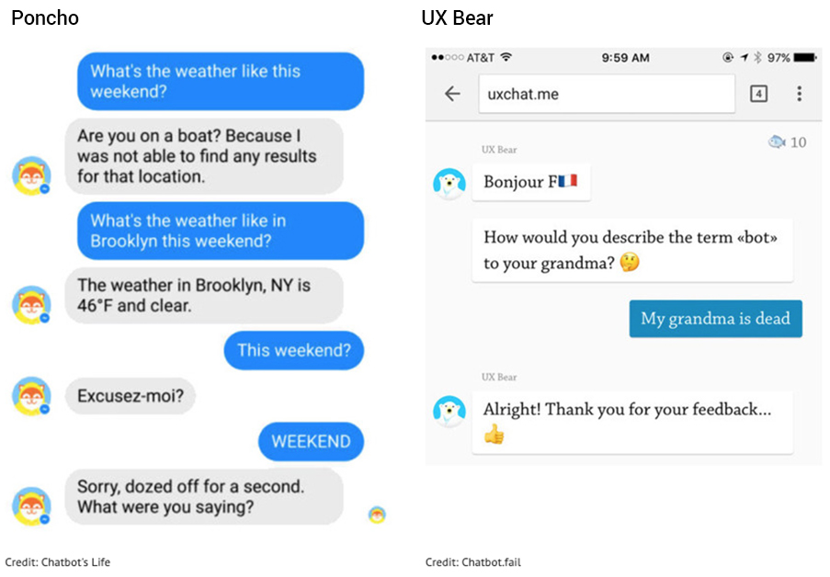

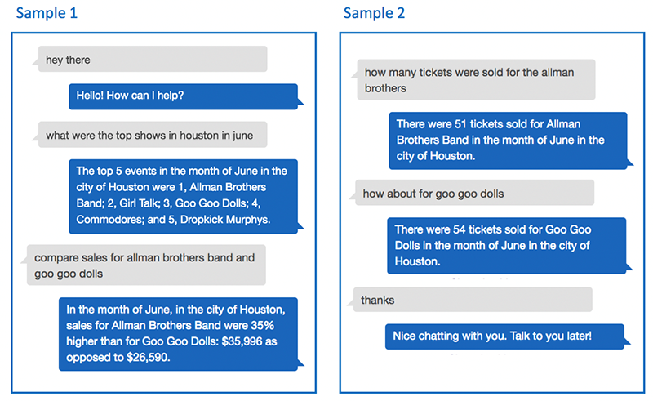

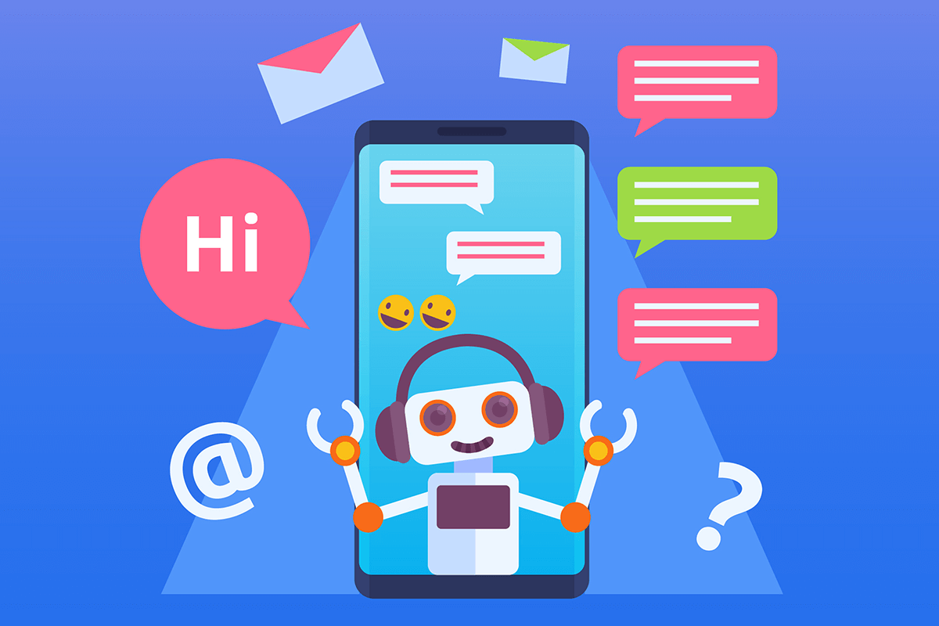

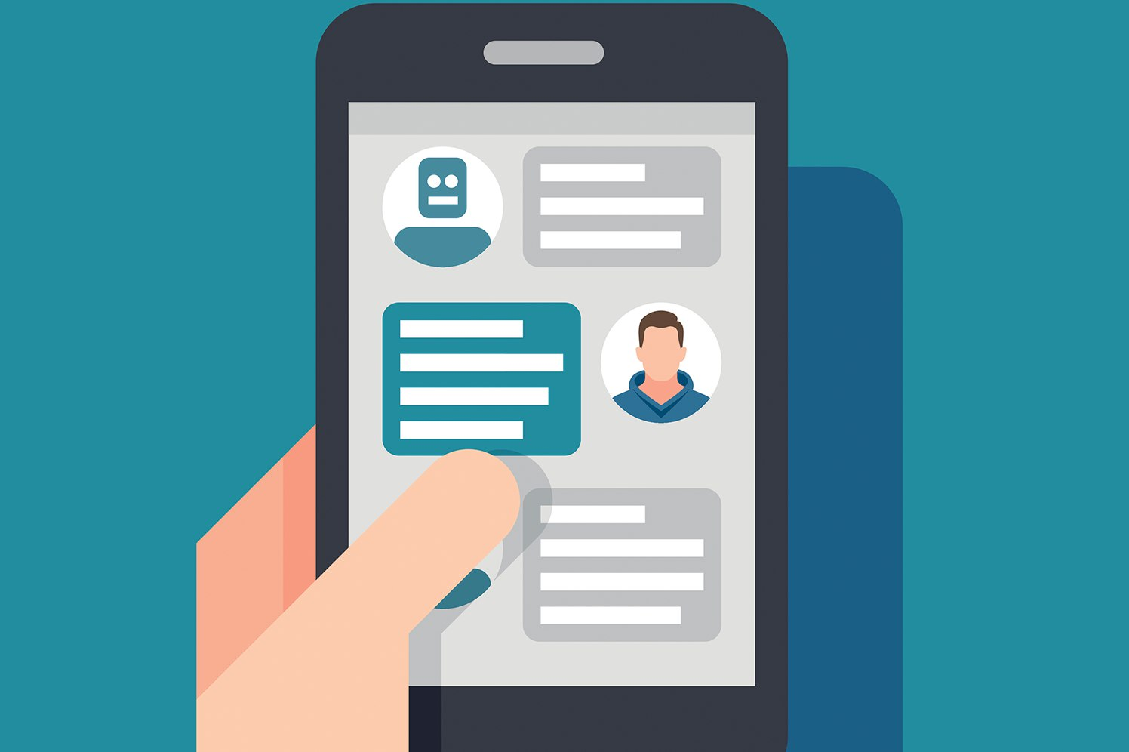

**User Interface :**

**Advantages of Chatbot :**

Humans can serve a limited number of clients at the same time. This restriction does not exist for chatbots, and they can manage all necessary queries simultaneously.

Their main advantages are:

* **Reduced costs:** Chatbots eliminate the need for labor during online interaction with customers. This is obviously a great advantage for companies that receive multiple queries at once. In addition to saving costs with them, companies can align the chatbot with their objectives, and use them as a means to enhance customer conversion.
* **24/7 Availability:** Unlike humans, once we install a chatbot, it can handle queries at any time of day. Thus, the customer does not have to wait for a commercial of the company to help him. This also allows companies to monitor customer “traffic” during non-working hours and contact them later.
* **Learning and updating:** AI-based chatbots are able to learn from interactions and update independently. This is one of the main advantages. When you hire a new employee, you have to train them continuously. However, chatbots “form” themselves (with certain limitations, of course).
* **Management of multiple clients:** Humans can serve a limited number of customers at the same time. This restriction does not exist for chatbots, and they can manage all the necessary queries simultaneously. This is one of the main advantages of using chatbot, as no customer is left unattended and you are solving different problems at the same time. There are chatbots companies already working on developing voice chatbot services.

**Disadvantages of chatbot :**

* Complex Interface – Chatbots are often seen to be complicated and require a lot of time to understand user’s requirement. It is also the poor processing which is not able to filter results in time that can annoy people.
* Inability to Understand – Due to fixed programs, chatbots can be stuck if an unsaved query is presented in front of them. This can lead to customer dissatisfaction and result in loss. It is also the multiple messaging that can be taxing for users and deteriorate the overall experience on the website.
* Time-Consuming – Chatbots are installed with the motive to speed-up the response and improve customer interaction. However, due to limited data-availability and time required for self-updating, this process appears more time-taking and expensive. Therefore, in place of attending several customers at a time, chatbots appear confused about how to communicate with people.
* Increased Installation Cost – Chatbots are useful programs that help you save a lot of manpower by ensuring the all-time availability and serving to several clients at once. But unlike humans, every chatbot needs to be programmed differently for a new business which increases the initial installation cost. This also increases the time needed to prepare for the program and plan everything effectively. Considering the last-minute changes that can always happen, this is a risky investment as updating the program will invite added costs to it.
* Zero decision-making – Chatbots are known for being infamous because of their inability to make decisions. A similar situation has landed big companies like Microsoft etc. in trouble when their chatbot went on making a racist rant. Therefore, it is critical to ensure proper programing of your chatbot to prevent any such incident which can hamper your brand.
* Poor Memory – Chatbots are not able to memorize the past conversation which forces the user to type the same thing again & again. This can be cumbersome for the customer and annoy them because of the effort required.

**Chatbot in future :**

* **Artificial intelligence is the hottest talking point for business users looking to improve their efficiency, deliver new ideas and take the next steps in the transition to a digital enterprise. AI and chatbots are helping democratise business, empower startups and help build new partnerships, something that every organisation needs to prepare for.**
* **“Every business is a technology business” was one of the mantras of the decade just concluded. Every company across every vertical and market started working and communicating with smartphones, using cloud services to open up their data and adopted as-a-service solutions to reduce the cost of doing business and broaden their business base and the opportunities for workers.**
* **ten years ago, specialists were needed to manage databases and build websites. Now anyone with a plan can build an entire company out of off-the-shelf parts, sell across the world without leaving their desk. They can pick advice from a huge range of sources to grow the business and partner with a massive range of organisations to deliver whatever they sell.**

**Conclusion :**

Chatbots are very effective way to organize your schedule. Now there are many Smart Personal Digital Applications available in market for various sevice platforms.

These new software applications are performing really well than PDA devices

as they provided with all resources of your own device. Chatbots are also more reliable than humans because they are more portable and you can use them anytime. They also have lot of information than any assistant as they are connected with internet.

